Communication System Practical file

**Submitted by:**

Mohak Sharma 01220802719

CSE-A

# Experiment -1

**Aim:-** To study Balanced modulator for DSB-SC modulation, demodulation.

**Software Used:-** MATLAB

**Theory:-** In Balanced modulator, two non-linear devices are connected in the balanced mode, so as to suppress the carrier wave.

The Balanced Modulator consists of summing devices (operational amplifiers) and two matched nonlinear elements. If x(t) is band limited to fx and if fc>2fx, then the band pass filter output will be the desired product signal.

Its carrier suppression is rated at a minimum of -50dB with a typical value -65dB at 500 KHz.

## Code:-

f1=input('enter the baseband signal frequency') f2=input('enter the carrier signal frequency')

T=input('enter the duration over which the signal is to be plotted') fs=input('enter the sampling frequency')

t=0:T/fs:T;

M=cos(2*pi*f1*t);

N=cos(2*pi*f2*t);

O=M.*N;

P=O.*N;

C=input('enter the value of the capacitor of the filter') R=1/(2*pi*f1*C); H=(1/(R*C))*exp(-t/(R*C)); h=conv(H,conv(P,H));

t1=t;

for i=length(t)+1:length(h) t1(i)=0;

end subplot(2,2,1) plot(t,M)

title('Baseband Signal') subplot(2,2,2) plot(t,N)

title('Carrier Signal') subplot(2,2,3) plot(t,O)

title('Modulated Carrier') subplot(2,2,4)

plot(t1,h) title('Demodulated Signal')

**Output:**

# Experiment-2

**Aim:-** To study the function of Amplitude Modulation & Demodulation (under modulation, perfect modulation & over modulation) and also to calculate the modulation index.

**Software Used:-** MATLAB

**Theory:-** Amplitude modulation (AM) is defined as a process in which the amplitude of the carrier wave c(t) is varied about a mean value, linearly with the base band signal m(t). An AM wave may thus be described, in its most general form, as a function of time as follows.

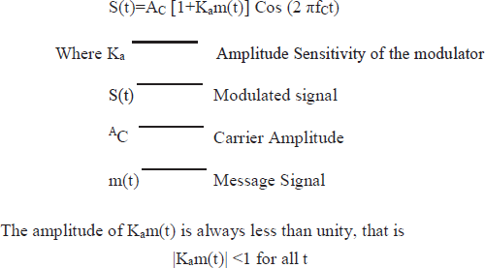

It ensures that the function 1+Kam(t) is always positive. When the amplitude sensitivity Ka of the modulator is large enough to make

|Kam(t)| >1 for any t, the carrier wave becomes over modulated, resulting in carrier phase reversals. Whenever the factor 1+Kam(t) crosses zero. The modulated wave then exhibits envelope distortion as shown in fig. below.

The absolute maximum value of Kam(t) multiplied by 100 is referred to as the percentage modulation.

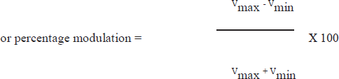

The carrier frequency fc is much greater than the highest frequency component w of the message signal m(t), that is

fC >>W Where W is the message bandwidth.

If this condition is not satisfied, envelope cannot be visualized (and therefore detected) satisfactorily.

**PHYSITECH**’S modulation and demodulation trainer has a carrier generator, which generates carrier wave of 100KHz when the trainer is switched on.

The blocks, carrier generator, modulator and demodulator are provided with built in supplies, no supply connections are to be given externally.

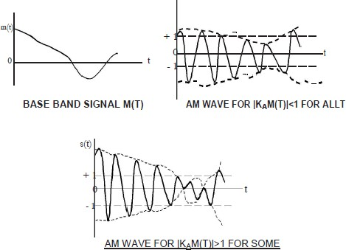

## Code:-

A=input('enter the carrier signal peak') B=input('enter the baseband signal peak') f1=input('enter the baseband signal frequency') f2=input('enter the carrier signal frequency') fs=input('enter the sampling frequency') t=0:0.001:1;

M=cos(2*pi*f1*t); N=cos(2*pi*f2*t); m=B/A; O=A*(1+m*M).*N; O1=O;

for i=1:length(t) if O1(i)<=0 O1(i)=0;

end end

[den, num]=butter(2,2*pi*f1/fs); M1=filter(den,num,O1); M11=filter(den,num,M1); M12=filter(den,num,M11); M13=filter(den,num,M12); subplot(5,1,1)

plot(t,M) title('Baseband signal') subplot(5,1,2) plot(t,N)

title('Carrier signal') subplot(5,1,3) plot(t,O);

title('Modulated Carrier') subplot(5,1,4)

plot(t,O1)

title('Rectified Modulated Signal') subplot(5,1,5)

plot(t,M13) title('Demodulated Signal')

## Output:-

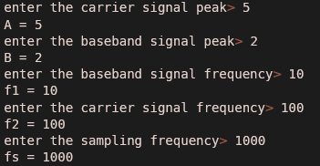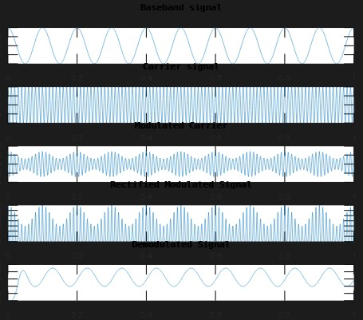

**Experiment-3**

**Aim:-** To generate SSB using phase method and demodulation of SSB signal using Synchronous detector.

**Software Used:-** MATLAB

**Theory:-** The phase shift method makes use of two balanced modulators and two phase shift networks as shown in fig. One of the modulators receives the carrier signal shifted by 900 and the modulating signal with 00 (sine)phase shift, whereas the other receives modulating signal shifted by 900 (co-sine) and the carrier (RF) signal with 00 phase shift voltage.

Both modulators produce an output consisting only of sidebands. It will be shown that both upper sidebands lead the input carrier voltage by 900. One of the lower sidebands leads the reference voltage by 900, and the other lags it by 900. The two lower sidebands are thus out of phase, and when combined in the adder, they cancel each other. The upper sidebands are in phase at the adder and therefore they add together and gives SSB upper side band signal. When they combined in the subtractor, the upper side bands are cancelled because in phase and lower side bands add together and gives SSB lower side band signal.

## Code:-

f1=input('enter the base band signal frequency') f2=input('enter the carrier signal frequency') t=0:0.001:0.4;

fs=input('enter sampling frequency')

M=cos(2*pi*f1*t); N=cos(2*pi*f2*t); DSB1=M.*N;

M1=cos(2*pi*f1*t-(pi/2)); N1=cos(2*pi*f2*t-(pi/2)); DSB2=M1.*N1; USB=DSB1-DSB2; LSB=DSB1+DSB2;

subplot(5,1,1) plot(t,M,'k',t,M1,'--b')

title('Base band signal and its Hilbert Transform') subplot(5,1,2)

plot(t,N,'k',t,N1,'--b')

title('Carrier Signal and its Hilbert Transform') subplot(5,1,3)

plot(t,USB)

title('Upper side band signal') subplot(5,1,4)

plot(t,LSB)

title('Lower Side band Signal') USBMULT=USB.*N;

[den num]= butter(2,(2*pi*f1)/fs);

Filter1=filter(den,num,USBMULT); Filter2=filter(den,num,Filter1); Filter3=filter(den,num,Filter2); Filter4=filter(den,num,Filter3); subplot(5,1,5)

plot(t,Filter4)

title('Demodulated Signal from USB')

**Output:-**

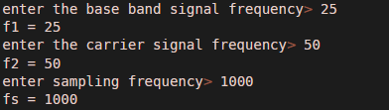

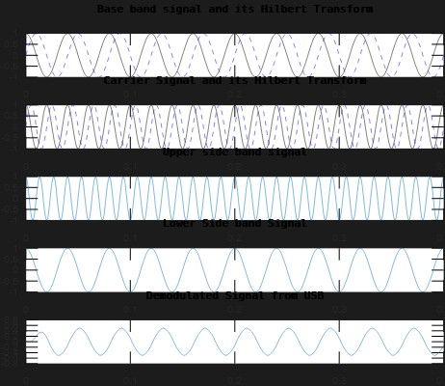

# Experiment-4

**Aim:-** To study the functioning of frequency modulation & demodulation and to calculate the modulation index.

**Software Used:-** MATLAB

**Theory:-** FM is a system in which the amplitude of the modulated carrier is kept constant, while its frequency and rate of change are varied by the modulating signal.

By the definition of FM, the amount by which the carrier frequency is varied from its unmodulated value, called the deviation, is made proportional to the instantaneous amplitude of the modulating voltage. The rate at which this frequency variation changes or takes place is equal to the modulating frequency.

FM is that form of angle modulation in which the instantaneous frequency fi(t) is varied linearly with the message signal m(t), as

fi(t) =fC+kf m(t)

The term fc represents the frequency of the unmodulated carrier, and the constant Kf represents the frequency sensitivity of the modulator expressed in Hertz per volt.

Unlike AM, the spectrum of an FM signal is not related in a simple manner to that of modulating signal, rather its analysis is much more difficult than that of an AM signal.

## Generation of FM signals:

There are essentially two basic methods of generating frequency modulated signals, namely, direct FM and indirect FM. In the direct method, the carrier frequency is directly varied in accordance with the input base band signal, which is readily accomplished using a voltage- controlled oscillator. In the indirect method, the modulating signal is first used to produce a narrow band FM signal, and frequency multiplication is next used to increase the frequency deviation to the

desired level. The indirect method is the preferred choice for FM when the stability of carrier frequency is of major concern as in commercial radio broad casting.

## Indirect FM :

A simplified block diagram of an indirect FM system is shown in fig below.

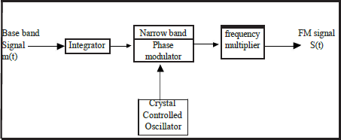

## Demodulation of fm signals:

Frequency demodulation is the process that enables us to recover the original modulating signal from a frequency – modulated signal. Here we describe a direct method of frequency demodulation involving the use of popular device known as a frequency discriminator, whose instantaneous output amplitude is directly proportional to the instantaneous frequency of the input FM signal.

Basically, the frequency discriminator consists of a slope circuit followed by an envelope detector.

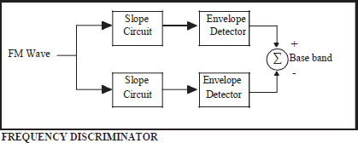

## Code:-

clc; clear all; close all;

fs=10000;

ac=1; am=1; fm=35; fc=500; b=10;

t=(0:0.1*fs)/fs; wc=2*pi*fc; wm=2*pi*fm; mt=am*cos(wm*t); subplot(4,1,1);

plot(t,mt); title('modulating signal'); ct=ac*cos(wc*t); subplot(4,1,2);

plot(t,ct); title('carrier signal');

st=ac*cos((wc*t)+b*sin(wm*t)); subplot(4,1,3);

plot(t,st); title('modulated signal'); d=demod(st,fc,fs,'fm'); subplot(4,1,4);

plot(t,d); title('demodulated signal');

**Output:-**

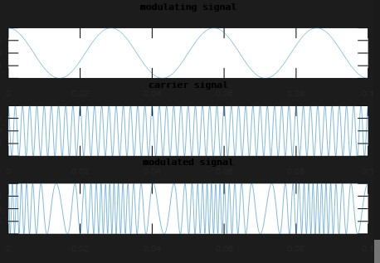

# Experiment – 5

**Aim:-** To study the functioning of Pre-Emphasis and De-Emphasis circuits.

**Software Used:-** MATLAB

**Theory:-** Frequency modulation is much more immune to noise than amplitude modulation and is significantly more immune than phase modulation. The threshold effect is more serious in FM as compared to AM, becausein FM, the signal to noise ratio at the input of a detector, at which threshold effect starts, is higher. Lower the threshold level, better is thesystem because threshold can be avoided at a comparatively lower ratio, and a small signal is needed to avoid threshold for an equivalent noise power. Hence, it is desirable to lower the threshold level in the FM receivers. The process of lowering the threshold level is known as threshold improvement, or threshold reduction. Two methods are usedfor the improvement of the threshold. Pre-Emphasis and De-Emphasis circuits.

FMFB (Frequency Modulation with Feedback)

## PRE-EMPHASIS AND DE-EMPHASIS:

The noise triangle shows, noise has a greater effect on the higher modulating frequencies than on the lower ones. Thus, if the higher frequencies were artificially boosted at the transmitter and correspondingly cut at the receiver, an improvement in noise immunity could be expected, thereby increasing the signal-to-noise ratio. This boosting of the higher modulating frequencies, in accordance with a prearranged curve, is termed pre-emphasis, and the compensation atthe receiver is called de-emphasis.

## Code:-

clc;

close all; clear all;

num_samples = 2^13;fs=5000;

Ts=1/f s; fm1=2 0;

fm2=3 0;

fc=200

;

t=(0:num_samples-1)*Ts;

f=(-num_samples/2:num_samples/2-1)*fs/num_samples; mt=sin(2*pi*fm1*t);

Mf=fftshift(abs(fft(mt))); f_cutoff_pe=15; Wn_pe=f_cutoff_pe/(fs/2); [b_pe,a_pe]=butter(1,Wn_pe); [H_pe,W]=freqz(a_pe,b_pe); a_de=b_pe;

b_de=a_pe; [H_de,W]=freqz(a_de,b_de); mt_pe=filter(a_pe,b_pe,mt); Mf_pe=fftshift(abs(fft(mt_pe)))

; figure(1) subplot(211);plot(t,mt)

axis([0 .6 min(mt)-1 max(mt)+1])

grid on; title('Modulating Signal (Time Domain)') subplot(212);plot(f,Mf)

grid on;axis([-50 50 0 max(Mf)+100])

title('Modulating Signal (Frequency Domain)')figure(2)

subplot(211) semilogx(W*pi*(fs/2),abs(H_pe),'m','linewidth',2) axis([0 fs/2 0 50])

grid on;title('Pre-emphasis Filter Magnitude Response')subplot(212) semilogx(W*pi*(fs/2),abs(H_de),'m','linewidth',2) axis([0 fs/2 0 1])

grid on;title('De-emphasis Filter Magnitude Response')

**Output:-**

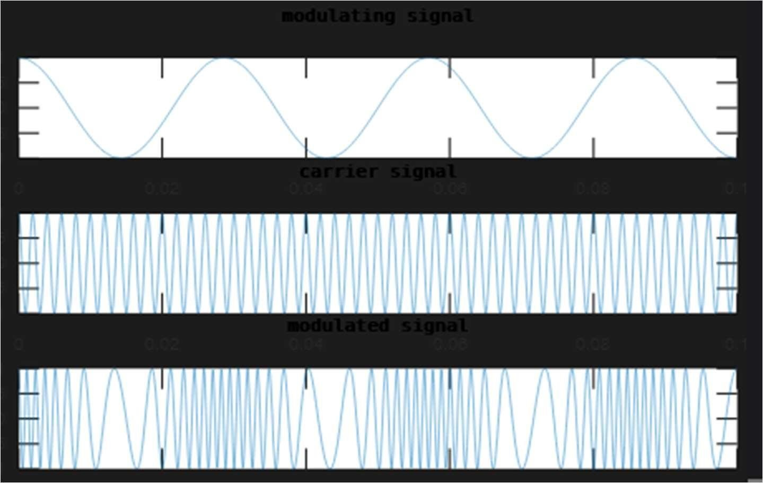

# EXPERIMENT - 6

**Aim:-** To study the Pulse Amplitude modulation and de-modulation and their waveforms.

**Software Used:**- MATLAB

## Theory:-

Pulse Amplitude Modulation (PAM) is the simplest and most basic form of analog pulse modulation, In PAM, the amplitudes of regularly spaced pulses are varied in proportional

to the corresponding sample values of a continuous message signal; the pulses can be of a

rectangular form or some other appropriate shape.

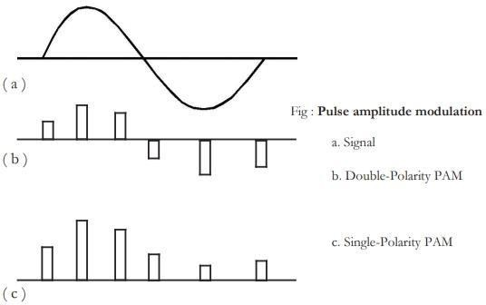

PAM is a pulse modulation system in which the signal is sampled at regular intervals, and each sample is made proportional to the amplitude of the signal at the instant of sampling.

The pulses are then sent by either wire or cable, or else are used to modulate a carrier. The two types of PAM are shown in fig. above. The two types are Double-polarity PAM, and single-polarity PAM. The largest pulse represents the greatest positive signal amplitude sampled, while the smallest pulse represents the largest negative sample. The time duration of each pulse may be quite short, and the time interval between pulses may be relatively long. In single-polarity PAM, in which a fixed dc level is added to the signal, to ensure that the pulses are always positive. The ability to use constant-amplitude pulses is a major advantage of pulse modulation and since PAM does not utilize constant amplitude pulses, it is infrequently used. When it is used, the pulses frequency modulate the carrier.

If a radio frequency is pulse-amplitude modulated instead of simply being amplitude modulated, much less power is required for the transmission of information because the transmitter is actually switched off between pulses. This is one advantage of pulse modulation.

It is very easy to generate and demodulate PAM. In a generator the signal to be converted to PAM is fed to one input of an AND gate.

Pulses at the sampling frequency are applied to the other input of the AND gate to open it during the wanted time intervals. The output of the gate then consists of pulses at the sampling rate, equal in amplitude to the signal voltage at each instant. The pulses are then passed through a pulse-shaping network, which gives them flat tops.

Frequency modulation is then employed, so that the system becomes PAM-FM. In the receiver, the pulses are first recovered with a standard FM de-modulator. They are then fed to an ordinary diode detector, which is followed by a low-pass filter. If the cutoff frequency of this

filter is high enough to pass the highest signal frequency, but low enough to

remove the Sampling frequency ripple, an undistorted replica of the original signal is reproduced.

**Code**:-

% pulse amplitude modulation close all

clear all clc

t = 0 : 1/1e3 : 3; % 1 kHz sample freq for 1 sec d = 0 : 1/5 : 3;

x = sin(2*pi/4*2*t);

%message signal figure;

subplot(4,1,1) plot(x); title('message ');

xlabel('time'); ylabel('amplit ude');

y = pulstran(t,d,'rectpuls',0.1); %generation of pulse input subplot(4,1,2)

plot(y);

title('Pulse Input ');

xlabel('time'); ylabel('amplitude')

; z=x.*y; % PAM output subplot(4,1,3)

plot(z);

title('PAM modulation '); xlabel('time'); ylabel('amplitude');

[den, num]=butter(1,2*pi*0.5/10 00); s11=filter(den,num,z); s12=filter(den,num,s11); subplot(4,1,4)

plot(t,s12) axis([0 3.5 -

1 1]);

title('filtered signal')

**Output:-**

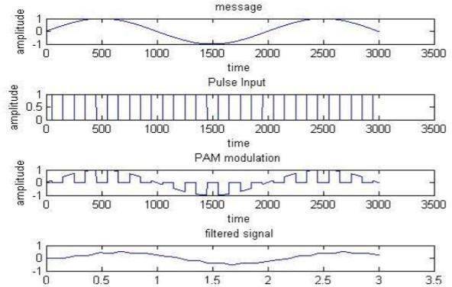

# EXPERIMENT – 7

**Aim**:- To study the Pulse Width Modulation (PWM) and Demodulation process and record the corresponding waveforms

**Software Used**:- MATLAB

## Theory:-

The Pulse-width modulation of PTM is also called as Pulse-duration modulation (PDM), or pulse length modulation (PLM). In this modulation, the pulses have a constant amplitude and a variable time duration. The time duration (or width) of each pulse is proportional to the instantaneous amplitude of the modulating signal.

In this system, as shown in fig. below, we have a fixed amplitude and starting time of watch pulse, but the width of each pulse is made proportional to the amplitude of the signal at that instant. In this case, the narrowest pulse represents the most negative sample of the original signal and the widest pulse represents the most positive sample.

When PDM is applied to radio transmission, the carrier frequency has constant amplitude, and the transmitter on time is carefully controlled in some circumstances, PDM can be more accurate than PAM. One example of this is in magnetic tape recording, where pulse widths can be recorded and reproduced with less error than pulse amplitudes.

PWM or PPM are not used in telephony. To use PWM or PPM in such an application, we have to ensure that full scale modulation will not cause a pulse from one message signal to enter a time slot belonging

to another message signal. This restriction results in a wasteful use of time space in telephone systems that are characterized by high peak factors.

## Code:-

% pulse width modulation & demodulation close all

clear all clc fc=1000; fs=1000 0; f1=200;

t=0:1/fs:((2/f1)-(1/fs)); x1=0.4*cos(2*pi*f1*t)

+0.5;

%modulation y1=modulate(x1,fc,fs,'pw m'); subplot(411); plot(x1);

axis([0 100 0 1]);

title('modulating signal,f1=200,fs=10000') subplot(412);

plot(y1);

axis([0 1000 -0.2 1.2]);

title('PWM')

%demodulation x1_recov=demod(y1,fc,fs,'p

wm'); [den, num]=butter(1,2*pi*f1/fs); s11=filter(den,num,x1_recov

); s12=filter(den,num,s11); subplot(413); plot(x1_recov);

title('time domain recovered, single

tone,f1=200') axis([0 100 0 1]); subplot(414);

plot(s12); title('filtered output') axis([0 100 0 1]);

**Output:-**

# EXPERIMENT - 8

**Aim**:- To study the Pulse Position Modulation (PPM) and demodulation process and record corresponding waveforms.

**Software Used**:- MATLAB

## Theory:-

Pulse position modulation (PPM) is more efficient than PAM or PDM for radio transmission. In PPM all pulses have the same constant amplitude and narrow pulse width. The position in time of the pulses is made to vary in proportion to the amplitude of the modulating signal. The simplest modulation process for pulse position modulation is a PDM system with the addition of a monostable multivibrator. The monostable is arranged so that it is triggered by the trailing edges of the PDM pulses. Thus, the monostable output is a series of constant-width, constant amplitude pulses which vary in position according to the original signal amplitude.

## Code:-

% pulse position modulation close all clear

all clc fc=10 0;

fs=10

00; f1=80;

t=0:1/fs:((2/f1)- (1/fs)); x1=0.4*cos(2*pi*f1*t

)+0.5;

%modulation y1=modulate(x1,fc,fs,'p pm'); subplot(311); plot(x1);

axis([0 15 0 1]);

title('modulating signal,f1=80,fs=1000') subplot(312); plot(y1);

axis([0 250 -0.2 1.2]);

title('PPM')

%demodulation x1_recov=demod(y1,fc,fs,' ppm'); subplot(313); plot(x1_recov);

title('time domain recovered, single

tone,f1=80') axis([0 15 0 1]);

## Output:-

